How to Land on Mars 2

The MOLA Map 4

Project 10: Selecting Martian Landing Sites 6

Strategy 7

The Site Selector Code 8

Importing Modules and Assigning User Input Constants 9

Assigning Derived and Fixed Constants and Creating the Screen Object 11

Defining and Initializing a Search Class 16

Calculating Rectangle Statistics 17

Checking the Rectangle Locations 19

Sorting the Statistics and High Grading the Rectangles 21

Drawing the Filtered Rectangles on the Map 22

Making the Final Color Display 24

Running the Program with main() 27

Results 28

Summary 29

Further Reading 29

Practice Project: Confirming that Drawings Become Part of an Image 30

Practice Project: Mixing Maps 30

Practice Project: Extracting an Elevation Profile 32

Practice Project: Plotting in 3D 33

Challenge Project: Making it Three in a Row 34

Challenge Project: Wrapping Rectangles 34

7

Selecting Martian Landing Sites

Landing a spacecraft on Mars is a major undertaking. No one wants to lose a billion-dollar probe, so engineers must emphasize operational safety. They may spend years searching satellite images for the safest landing sites that satisfy mission objectives. And they've got a lot of ground to cover. Mars has almost the same amount of dry land as Earth!

Analyzing an area this large requires the help of computers. In this chapter, you’ll use Python and the Jet Propulsion Laboratory’s pride-and-joy, the Mars Orbiter Laser Altimeter (MOLA) map, to choose and rank candidate landing sites for a Mars lander. To load and extract useful information from the MOLA map, you’ll use the Python Imaging Library, OpenCV, tkinter, and NumPy.

How to Land on Mars

There are many ways to land a probe on Mars, including with parachutes, balloons, retro rockets, and jet packs. Regardless of the method, most landings follow the same basic safety rules.

The first rule is to target low-lying areas. A probe may enter the Martian atmosphere going as fast as 27,000 kph. Slowing it down for a soft landing requires a nice thick atmosphere. But the Martian atmosphere is thin—roughly one percent the density of Earth’s. To find enough of it to make a difference, you need to aim for the lowest elevations, where the air is denser and the flight through it takes as long as possible.

Unless you have a specialty probe, like one designed for a polar cap, you’ll want to land near the equator. Here, you’ll find plenty of sunshine to feed the probe’s solar panels, and temperatures stay warm enough to protect the probe’s delicate machinery.

You’ll want to avoid sites covered in boulders that can destroy the probe, prevent its panels from opening, block its robotic arm, or leave it tilted away from the sun. For similar reasons, you’ll want to stay away from areas with steep slopes, such as those found on the rims of craters. From a safety standpoint, flat and boring is beautiful.

Another challenge of landing on Mars is that you can’t be very precise. It’s hard to fly fifty million kilometers or more, graze the atmosphere, and land exactly where you intended. Inaccuracies in interplanetary navigation, along with variances in Martian atmospheric properties, make hitting a small target very uncertain.

Consequently, NASA runs lots of computer simulations for each landing coordinate. Each simulation run produces a coordinate, and the scatter of points that results from thousands of runs forms an elliptical shape with the long axis parallel to the probe’s flight path. These landing ellipses can be quite large (Figure 7-1), though accuracy improves with each new mission. The 2018 Insight lander had a landing ellipse of only 130 km x 27 km. The probability of the probe landing somewhere within that ellipse was around 99%.

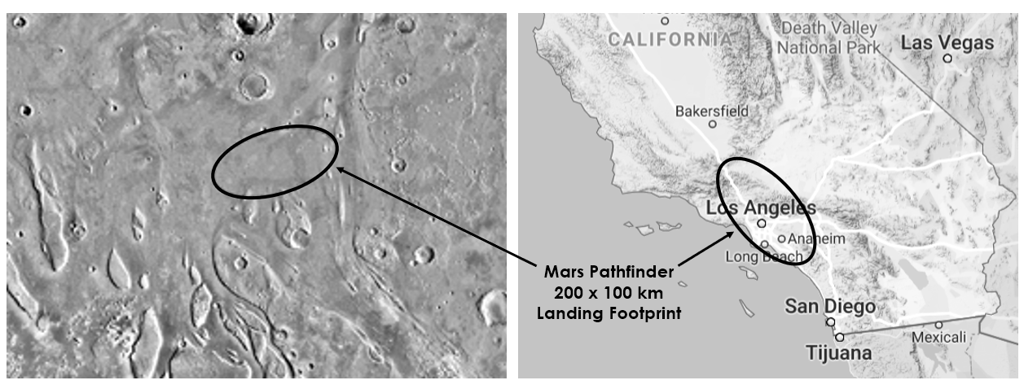

Figure 7-1: Scaled comparison of 1997 Mars Pathfinder landing site (left) with Southern California (right)

The MOLA Map

In order to identify suitable landing spots, you’ll need a map of Mars. Between 1997 and 2001, the Mars Orbiter Laser Altimeter tool aboard the Mars Global Surveyor spacecraft shined a laser on Mars and timed its reflection 600 million times. From these measurements, researchers led by Maria Zuber and David Smith produced a detailed global topography map known as MOLA (Figure 7-3).

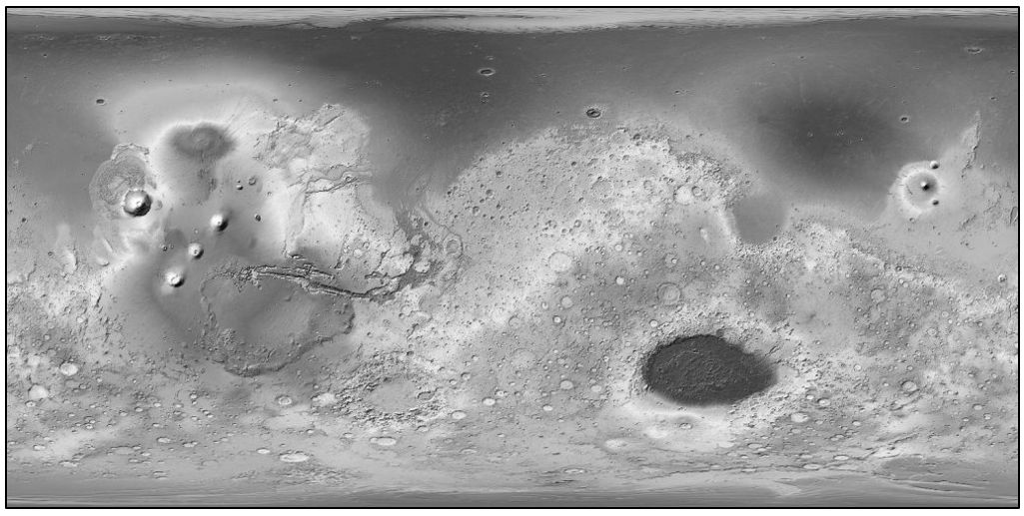

Figure 7-3: MOLA shaded relief map of Mars (courtesy of NASA)

To see the spectacular color version of MOLA, along with a legend, go to the Wikipedia page for the Mars Global Surveyor. The blues in this map correspond to where oceans and seas probably existed on Mars billions of years ago. Their distribution is based on a combination of elevation and diagnostic surface features, like ancient shorelines.

The laser measurements for MOLA have a vertical positional accuracy of around 3-13 m and a horizontal positional accuracy of about 100 m. Pixel resolution is 463 m per pixel. By itself, the MOLA map lacks the detail needed to safely choose a final landing ellipse, but it’s perfect for the scoping work you’ll be asked to do.

Project 10: Selecting Martian Landing Sites

Let’s pretend you’re a NASA summer intern working on the Orpheus Project, a lander designed to listen for marsquakes and study the interior of the planet, much like the 2018 Mars Insight mission. Because the purpose of Orpheus is to study the interior of Mars, interesting features of the planet’s surface aren’t that important. Safety is the prime concern, making this mission an engineer’s dream come true.

Your job is to find fifteen-to-twenty regions from which NASA staff can select smaller candidate landing ellipses. According to your supervisor, the regions should be rectangles 670 km long (E-W) and 335 km wide (N-S). To address safety concerns, the regions should straddle the equator between 30o N and 30o S latitude, lie at low elevations, and be as smooth and flat as possible.

begin box

The Objective

Write a Python program that uses an image of the MOLA map to choose the twenty safest 670 km x 335 km regions near the Martian equator from which to select landing ellipses for the Orpheus lander.

end box

Strategy

First, you’ll need a way to divide the MOLA digital map into rectangular regions and extract statistics on elevation and surface roughness. This means you’ll be working with pixels, so you’ll need imaging tools. And since NASA is always containing costs, you’ll want to use free, open source libraries, like OpenCV, the Python Imaging Library (PIL), tkinter, and NumPy. For an overview and installation instructions, see page XX in Chapter 1 for OpenCV and NumPy, and page XX in Chapter 3 for PIL. The tkinter module comes pre-installed with Python.

For honoring elevation constraints, you can simply calculate the average elevation for each region. For measuring how smooth a surface is at a given scale, you have a lot of choices, some of them quite sophisticated. Besides basing smoothness on elevation data, you can look for differential shadowing in stereo images; the amount of scattering in radar, laser, and microwave reflections; thermal variations in infrared images; and so on. Many roughness estimates involve tedious analyses along transects: lines drawn on the planet’s surface along which variations in height are measured and scrutinized. Since you’re not really a summer intern with three months to burn, you’re going to keep things simple and use two common measurements that you’ll apply to each rectangular region: standard deviation and peak-to-valley.

Standard deviation, also called root-mean-square by physical scientists, is a measure of the spread in a set of numbers. A low standard deviation indicates that the values in a set are close to the average value; a high standard deviation indicates they are spread out over a wider range. A map region with a low standard deviation for elevation means that the area is flattish, with little variance from the average elevation value.

Technically, the standard deviation for a population of samples is the square root of the average of the squared deviations from the mean, represented by the formula:

$$σ= \sqrt{\frac{1}{N}\sum_{i=1}^{N}{{(h_{i}-h_{0})}^{2}}}$$

where σ is the standard deviation, N is the number of samples, hi is the current height sample, and h0 is the mean of all the heights.

The peak-to-valley statistic is the difference in height between the highest and lowest points on a surface. It captures the maximum elevation change for the surface. This is important as a surface may have a relatively low standard deviation—suggesting smoothness—yet contain a significant hazard, as shown in the cross section in Figure 7-4.

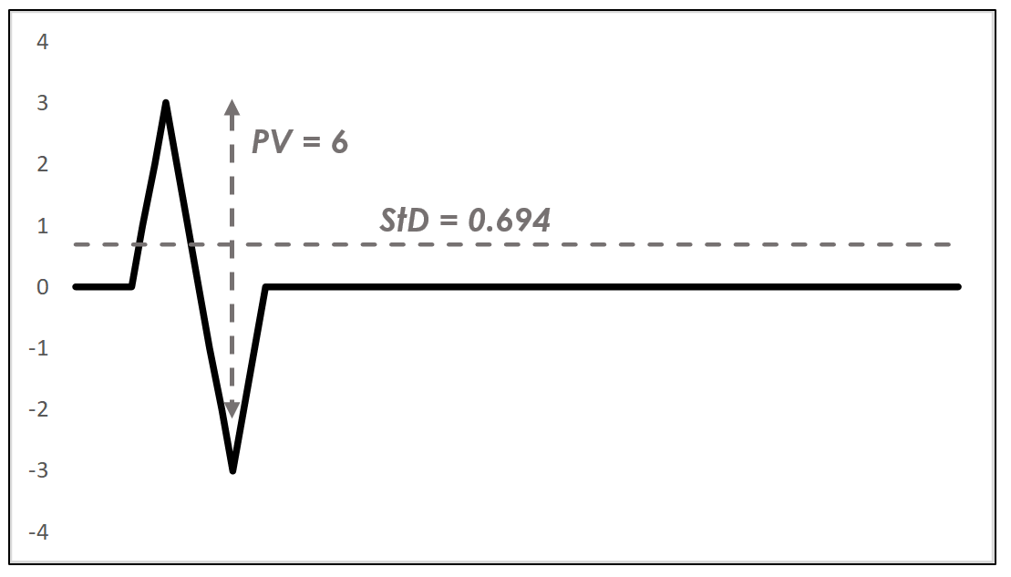

Figure 7-4: A surface profile (black line) with standard deviation (StD) and peak-to-valley (PV) statistics

You can use the standard deviation and peak-to-valley statistics as comparative metrics. For each rectangular region, you’re looking for the lowest values of each statistic. And because each statistic records something slightly different, you’ll find the best twenty rectangular regions based on each statistic, then select only the rectangles that overlap to find the very best rectangles, overall.

The Site Selector Code

The site_selector.py program uses a grayscale image of the MOLA map (Figure 7-5) to select the landing site rectangles and the shaded color map (Figure 7-3) to post them. Elevation is represented by a single channel in the grayscale image, so it’s easier to use than the three channel (RGB) color image.

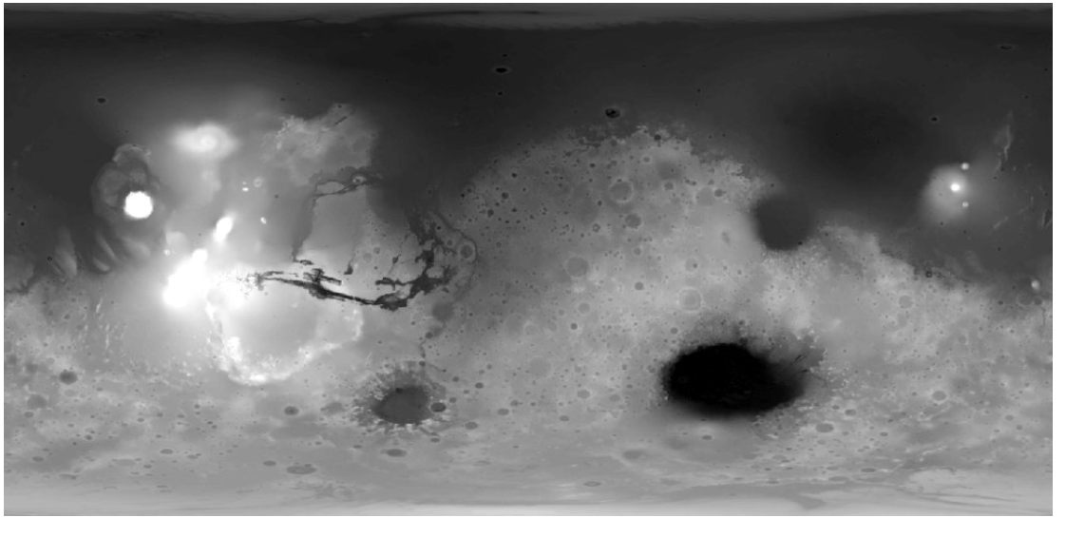

Figure 7-5: Mars MGS MOLA Digital Elevation Model 463m v2 (mola_1024x501.png)

You can find the program, the grayscale image (mola_1024x501.png), and the color image (mola_color_1024x506.png) in the Chapter_7 folder, downloadable from XXX. Keep these files together in the same folder and don’t rename them.

Note: The MOLA map comes in multiple file sizes and resolutions. You’re using the smallest size here to speed up the download and run times.

Importing Modules and Assigning User Input Constants

Listing 7-1 imports modules and assigns constants that represent user input parameters. These include image file names, the dimensions of the rectangular regions, a maximum elevation limit, and the number of candidate rectangles to consider.

➊import tkinter as tk

➋from PIL import Image, ImageTk

➌import numpy as np

import cv2 as cv

# CONSTANTS: User Input:

➍IMG_GRAY = cv.imread('mola_1024x501.png', cv.IMREAD_GRAYSCALE)

IMG_COLOR = cv.imread('mola_color_1024x506.png')

➎RECT_WIDTH_KM = 670 # Site rectangle width in kilometers.

RECT_HT_KM = 335 # Site rectangle height in kilometers.

➏MAX_ELEV_LIMIT = 55 # Intensity values (0-255).

➐NUM_CANDIDATES = 20 # Number of candidate landing regions to display.

MARS_CIRCUM = 21344 # Circumference in kilometers.

Listing 7-1: Imports modules and assigns user input constants, site_selector.py, Part 1

Start by importing the tkinter module ➊. This is Python’s default GUI library for developing desktop applications. You’ll use it to make the final display: a window with the color MOLA map at the top and a text description of the posted rectangles at the bottom. Most Windows, macOS, and Linux machines come with tkinter already installed. If you don’t have it or need the latest version, you can download and install it from <https://www.activestate.com/>. Online documentation for the module can be found at <https://docs.python.org/3/library/tk.html>.

Next, import the Image and ImageTK modules from the Python Imaging Library ➋. The Image module provides a class that represents a PIL image. It also provides factory functions, including functions to load images from files and create new images. The ImageTK module contains support for creating and modifying tkinter BitmapImage and PhotoImage objects from PIL images. Again, you’ll use these at the end of the program to place the color map and some descriptive text in a summary window. Finally, finish the imports with NumPy and OpenCV ➌.

Now, assign some constants that represent user input that won’t change as the program runs. First, use the OpenCV imread() method to load the grayscale MOLA image ➍. Note that you have to use the cv.IMREAD_GRAYSCALE flag, as the method loads images in color by default. Repeat the code without the flag to load the color image. Then add constants for the rectangle size ➎. In the next listing, you’ll convert these dimensions to pixels for use with the map image.

Next, to ensure the rectangles target smooth areas at low elevations, you should limit the search to lightly cratered, flat lying terrain. These regions are believed to represent old ocean bottoms. Thus, you’ll want to set the maximum elevation limit to a grayscale value of 55 ➏, which corresponds closely to the areas thought to be remnants of ancient shorelines (see Figure 7-6).

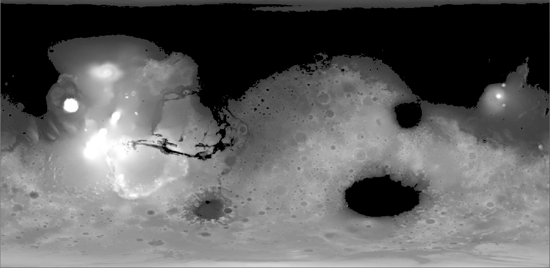

Figure 7-6: MOLA map with pixel values < 55 colored black to represent ancient Martian oceans.

Now, specify the number of rectangles to display ➐. Later, you’ll select these from a sorted list of rectangle statistics. Complete the user input constants by assigning a constant to hold the Martian circumference, in kilometers. You’ll use this later to determine the number of pixels per kilometer.

Assigning Derived Constants and Creating the Screen Object

Listing 7-2 assigns constants that are derived from other constants. These are values that will update automatically if the user changes the previous constants to, for example, test out different rectangle sizes or elevation limits. The listing ends by creating tkinter screen and canvas objects for the final display.

# CONSTANTS: Derived:

➊IMG_HT, IMG_WIDTH = IMG_GRAY.shape

➋PIXELS_PER_KM = IMG_WIDTH / MARS_CIRCUM

➌ RECT_WIDTH = int(PIXELS_PER_KM * RECT_WIDTH_KM)

RECT_HT = int(PIXELS_PER_KM * RECT_HT_KM)

➍ LAT_30_N = int(IMG_HT / 3)

LAT_30_S = LAT_30_N * 2

➎STEP_X = int(RECT_WIDTH / 2)

➏STEP_Y = int(RECT_HT / 2)

# Create tkinter screen and drawing canvas

➐screen = tk.Tk()

➑canvas = tk.Canvas(screen, width=IMG_WIDTH, height=IMG_HT + 130)

Listing 7-2: Assigns derived and fixed constants, site_selector.py, Part 2

Start by unpacking the height and width of the image using the shape attribute ➊. OpenCV stores images as NumPy ndarrays, which are n-dimensional arrays—or tables—of elements of the same type. For an image array, shape is a tuple of the number of rows, columns, and channels. Height represents the number of pixel rows in the image, and width represents the number of pixel columns in the image. Channels represent the number of components used to represent each pixel (such as red, green, and blue). For grayscale images with one channel, shape is just a tuple of the area’s height and width.

To convert the rectangle dimensions from kilometers to pixels, you need to know how many pixels there are per kilometer. So, divide the image width by the circumference to get the pixels per kilometer at the equator ➋. Then convert width ➌ and height into pixels. You’ll use these to derive values for index slicing later, so make sure they are integers by using int(). The value of these constants should now be 32 and 16, respectively.

You want to limit your search to the warmest and sunniest areas, which straddle the equator between 30o North latitude and 30o South latitude (Figure 7-7). In terms of climatic criteria, this region corresponds to the tropics on Earth.

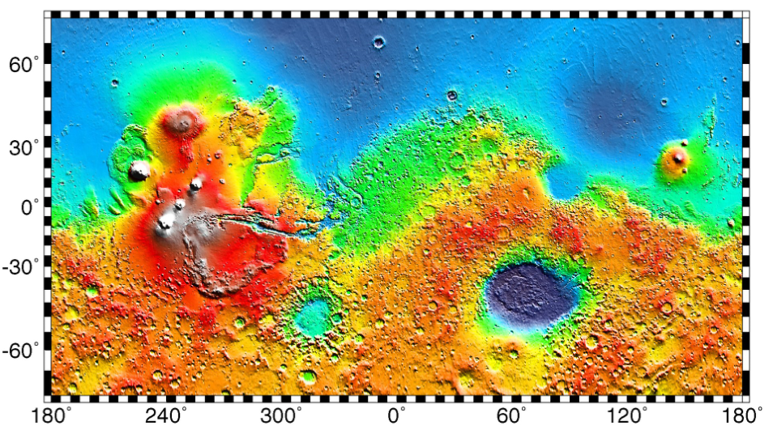

Figure 7-7: Latitude (y-axis) and longitude (x-axis) on Mars (Wikimedia Commons)

Latitude values start at 0o at the equator and end at 90o at the poles. To find 30o North, all you need to do is divide the image height by three ➍. To get 30o South, double the number of pixels it took to get to 30o North.

Restricting the search to the equatorial region of Mars has a beneficial side effect. The MOLA map you’re using is based on a Cylindrical Projection, used to transfer the surface of a globe onto a flat plane. This causes converging lines of longitude to be parallel, badly distorting features near the poles. You may have noticed this on wall maps of the Earth, where Greenland looks like a continent and Antarctica is impossibly huge (see Figure 7-8).

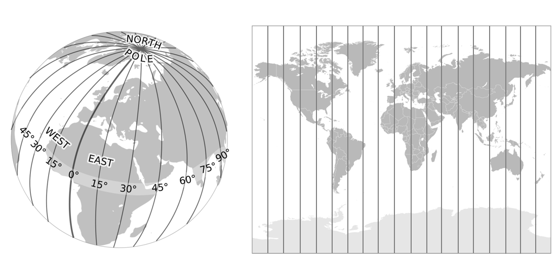

Figure 7-8: Forcing lines of longitude to be parallel distorts the size of features near the poles (courtesy Wikimedia Commons)

Fortunately, this distortion is minimized near the equator, so you don’t have to factor it into the rectangle dimensions. You can verify this by checking the shape of craters on the MOLA map. So long as they’re nice and circular—rather than oval—projection-related effects can be ignored.

Next, you’ll need to divide the map up into rectangular regions. A logical place to begin is the upper left corner, tucked under the 30o North latitude line (Figure 7-9).

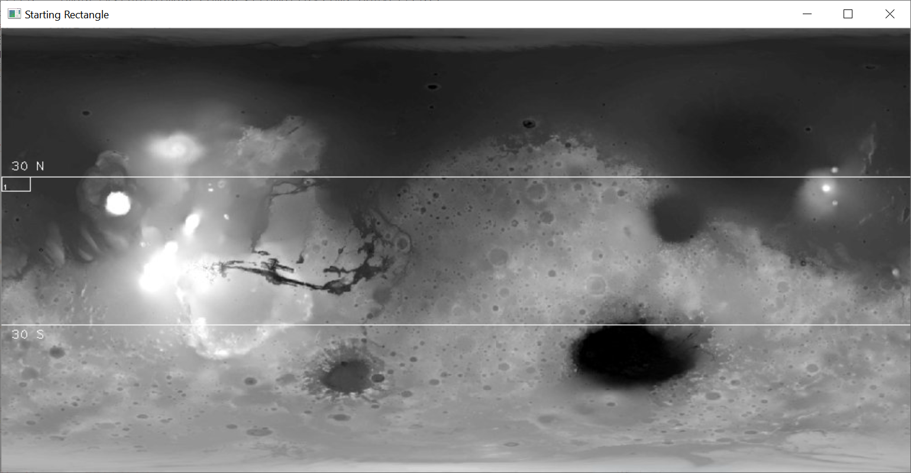

Figure 7-9: Position of the first numbered rectangle

The program will draw this first rectangle, number it, and calculate the elevation statistics within it. It will then move the rectangle eastward and repeat the process. How far you move the rectangle each time is defined by the STEP_X ➎ and STEP_Y ➏ constants and depends on something called aliasing.

Aliasing is a resolution issue. It occurs when you don’t take enough samples to identify all the important surface features in an area. This can cause you to “skip over” a feature, like a crater, and fail to recognize it. For example, in Figure 7-10A, there’s a suitably smooth landing ellipse between two large craters. However, as laid out in Figure 7-10B, no rectangular region corresponds to this ellipse; both rectangles in the vicinity partially sample a crater rim. As a result, none of the drawn rectangles contain a suitable landing ellipse, even though one exists in the vicinity. With this arrangement of rectangles, the ellipse in Figure 10-A is aliased. But shift each rectangle by half its width, as in Figure 7-10C, and the smooth area is properly sampled and recognized.

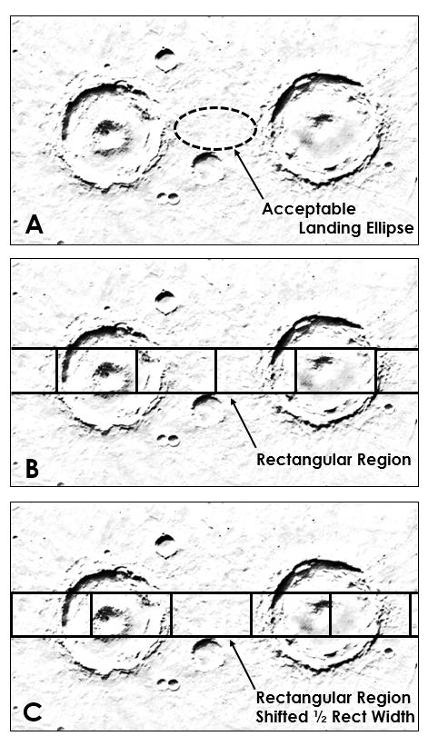

Figure 7-10: Example of aliasing due to rectangle positioning (photo courtesy of NASA)

The rule of thumb to avoid aliasing effects is to make the step size less than or equal to half the width of the smallest feature you want to identify. For this project, use half the rectangle width so the displays don’t become too busy ➎➏.

Now it’s time to look ahead to the final display. Create a screen instance of the tkinter Tk()class ➐. The tkinter application is Python’s wrapper of the GUI toolkit Tk, originally written in a computer language called TCL. It needs the screen window to link to an underlying tcl/tk interpreter that translates tkinter commands into tcl/tk commands.

Next, create a tkinter canvas object ➑. This is a rectangular drawing area designed for complex layouts of graphics, text, widgets, and frames. Pass it the screen object, set its width equal to the MOLA image, and set its height equal to the height of the MOLA image plus 130. The extra padding beneath the image will hold the text summarizing the statistics for the displayed rectangles.

It’s more typical to place the tkinter code just described at the end of programs, rather than at the beginning. I chose to put it near the top to make the code explanation easier to follow. You can also embed this code within the function that makes the final display. However, this can cause problems for macOS users. For macOS 10.6 or later, the Apple-supplied Tcl/Tk 8.5 has serious bugs that can cause application crashes (see <https://www.python.org/download/mac/tcltk/>).

Defining and Initializing a Search Class

Listing 7-3 defines a class that you’ll use to search for suitable rectangular regions. It then defines the class’s __init__() initialization method, used to instantiate new objects. For a quick overview of OOP, see Page XX in Chapter 1, where you also define a search class.

➊class Search():

"""Read image and identify landing rectangles based on input criteria."""

➋def __init__(self, name):

➌self.name = name

➍self.rect_coords = {}

self.rect_means = {}

self.rect_ptps = {}

self.rect_stds = {}

➎self.ptp_filtered = []

self.std_filtered = []

➏self.high_graded_rects = []

Listing 7-3: Defines the Search class and __init__() method, site_selector.py (Part 3)

Define a class called Search ➊. Then define the __init__() method used to create new objects ➋. The name parameter will allow you to give a personalized name to each object when you create it later in the main() function.

Now you’re ready to start assigning attributes. Start by linking the object’s name with the argument you’ll provide when you create the object ➌. Then assign four empty dictionaries to hold important statistics for each rectangle ➍. These include the rectangle’s corner-point coordinates and its mean elevation, peak-to-valley, and standard deviation statistics. For a key, all these dictionaries will use consecutive numbers, starting with one. These numbers are linked to the rectangle locations using the self.rect_coords dictionary.

You’ll want to filter the statistics to find the lowest values, so set up two empty lists to hold these ➎. Note that I use the term “ptp”, rather than “ptv”, to represent the peak-to-valley statistic. That’s to be consistent with the NumPy built-in method for this calculation, which is called “peak-to-peak.”

At the end of the program, you’ll place rectangles that occur in both the sorted standard deviation and peak-to-valley lists in a new list named high_graded_rects ➏. This list will contain the numbers of the rectangles with the lowest combined scores. These rectangles will be the best places to look for landing ellipses.

Calculating Rectangle Statistics

Still in the Search class, Listing 7-4 defines a method that calculates statistics in a rectangle, adds the statistics to the appropriate dictionary, and then moves to the next rectangle and repeats the process. The method honors the elevation limit by using the rectangles in low-lying areas only to populate the dictionaries.

➊def run_rect_stats(self):

"""Define rectangular search areas and calculate internal stats."""

➋ul_x, ul_y = 0, LAT_30_N

lr_x, lr_y = RECT_WIDTH, LAT_30_N + RECT_HT

➌rect_num = 1

➍while True:

➎rect_img = IMG_GRAY[ul_y : lr_y, ul_x : lr_x]

➏self.rect_coords[rect_num] = [ul_x, ul_y, lr_x, lr_y]

➐if np.mean(rect_img) <= MAX_ELEV_LIMIT:

self.rect_means[rect_num] = np.mean(rect_img)

self.rect_ptps[rect_num] = np.ptp(rect_img)

self.rect_stds[rect_num] = np.std(rect_img)

➑rect_num += 1

# Move the rectangle.

ul_x += STEP_X

lr_x = ul_x + RECT_WIDTH

➒if lr_x > IMG_WIDTH:

ul_x = 0

ul_y += STEP_Y

lr_x = RECT_WIDTH

lr_y += STEP_Y

➓if lr_y > LAT_30_S + STEP_Y:

break

Listing 7-4: Calculates rectangle statistics and moves the rectangle, site_selector.py (Part 4)

Define the run_rect_stats() method, which takes self as an argument ➊. Then assign local variables for the upper-left and lower-right corners of each rectangle. Initialize them using a combination of coordinates and constants ➋. This will place the first rectangle along the left side of the image with its top boundary at 30o North latitude.

Keep track of the rectangles by numbering them, starting with 1 ➌. These numbers will serve as the keys for the dictionaries used to record coordinates and stats. You’ll also use them to identify the rectangles on the map, as I demonstrated earlier in Figure 7-11.

Now, start a while loop that will automate the process of moving the rectangles and recording their statistics ➍. This loop will run until more than half of a rectangle extends below latitude 30o South, at which time the loop will break.

As mentioned previously, OpenCV stores images as NumPy arrays. To calculate the stats within the active rectangle, rather than the whole image, create a subarray using normal slicing ➎. Call this subarray rect_img, for “rectangular image.” Then, add the rectangle number and these coordinates to the rect_coords dictionary ➏. You’ll want to keep a record of these coordinates for the NASA staff, who’ll use your rectangles as the starting point for more detailed investigations later.

Next, start a conditional to check that the current rectangle is at or below the maximum elevation limit specified for the project ➐. As part of this statement, use NumPy to calculate the mean elevation for the rect_img subarray.

If the rectangle passes the elevation test, populate the three dictionaries with the coordinates, peak-to-valley, and standard deviation statistics, as appropriate. Note that you can perform the calculation as part of the process, using np.ptp for peak-to-valley and np.std for standard deviation.

Next, advance the rect_num variable by one ➑ and move the rectangle. Move the upper left x-coordinate by the step size, then shift the lower right x-coordinate by the width of the rectangle. You don’t want the rectangle to extend off the right side of the image, so check to see if lr_x is greater than the image width ➒. If it is, set the upper left x-coordinate to 0 to move the rectangle back to the starting position on the left side of the screen. Then move its y-coordinates down so that the new rectangles move along a new row. If the bottom of this new row is more than half a rectangle height below 30o South latitude, you’ve fully sampled the search area and can end the loop ➓.

Between 30o North and South latitude, the image is bounded on both sides by relatively high, cratered terrain that isn’t suitable for a landing site (see Figure 7-9). Thus, you can ignore the final step that shifts the rectangle by one half its width. Otherwise, you would need to add code that wraps a rectangle from one side of the image to the other and calculates the statistics for each part. We’ll take a closer look at this situation in the final challenge project at the end of the chapter.

Note: When you draw something on an image, such as a rectangle, the drawing becomes part of the image. The altered pixels will be included in any NumPy analyses you run, so be sure to calculate any statistics before you annotate the image.

Checking the Rectangle Locations

Still indented under the Search class, Listing 7-5 defines a method that performs quality control. It prints the coordinates of all the rectangles, then draws them on the MOLA map. This will let you verify that the search area has been fully evaluated and the rectangle size is what you expected it to be.

➊def draw_qc_rects(self):

"""Draw overlapping search rectangles on image as a check."""

➋img_copy = IMG_GRAY.copy()

➌rects_sorted = sorted(self.rect_coords.items(), key=lambda x: x[0])

print("\nRect Number and Corner Coordinates (ul_x, ul_y, lr_x, lr_y):")

➍for k, v in rects_sorted:

print("rect: {}, coords: {}".format(k, v))

➎cv.rectangle(img_copy,

(self.rect_coords[k][0], self.rect_coords[k][1]),

(self.rect_coords[k][2], self.rect_coords[k][3]),

(255, 0, 0), 1)

➏cv.imshow('QC Rects {}'.format(self.name), img_copy)

➐cv.waitKey(3000)

cv.destroyAllWindows()

Listing 7-5: Draws all the rectangles on the MOLA map as a quality control step, site_selector.py (Part 5)

Start by defining a method to draw the rectangles on the image ➊. Anything you draw on an image in OpenCV becomes part of the image, so first make a copy of the image in the local space ➋.

You’ll want to provide NASA with a printout of the identification number and coordinates for each rectangle. To print these in numerical order, sort the items in the rect_coords dictionary using a lambda function ➌. If you haven’t used lambda before, you can find a short description on Page XX in Chapter 5.

Print a header for the list, then start a for loop through the keys and values in the newly sorted dictionary ➍. The key is the rectangle number, and the value is the list of coordinates, as shown in the following output:

Rect Number and Corner Coordinates (ul_x, ul_y, lr_x, lr_y):

rect: 1, coords: [0, 167, 32, 183]

rect: 2, coords: [16, 167, 48, 183]

—snip—

rect: 1259, coords: [976, 319, 1008, 335]

rect: 1260, coords: [992, 319, 1024, 335]

Use the OpenCV rectangle() method to draw the rectangles on the image ➎. Pass it the image on which to draw, the rectangle coordinates, a color, and a line width. Access the coordinates directly from the rect_coords dictionary using the key and the list index (0 = upper left x, 1 = upper left y, 2 = lower right x, 3 = lower right y).

To display the image, call the OpenCV imshow() method and pass it a name for the window and the image variable ➏. The rectangles should cover Mars in a band centered on the equator (Figure 7-11). Leave the window up for three seconds ➐, then destroy it.

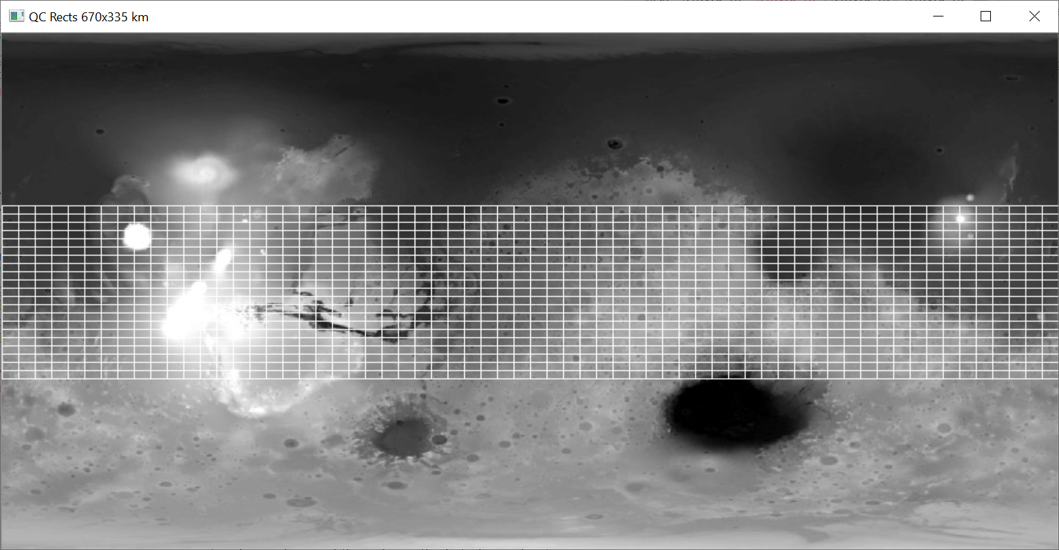

Figure 7-11: All 1,260 rectangles drawn on the MOLA image by the draw_qc_rects() method

If you compare Figure 7-11 to Figure 7-9, you may notice that the rectangles appear smaller than expected. his is because you stepped the rectangles across and down the image using half the rectangle width and height, so that they overlap each other.

Sorting the Statistics and High Grading the Rectangles

Continuing with the Search class definition, Listing 7-6 defines a method to find the rectangles with the best potential landing sites. It sorts the dictionaries containing the rectangle statistics, makes lists of the top rectangles based on peak-to-valley and standard deviation, then makes a list of any rectangles shared between these two lists. The shared rectangles will be the best candidates for landing sites, as they’ll have the smallest peak-to-valley and standard deviation stats.

➊def sort_stats(self):

"""Sort dictionaries by values and create lists of top N keys."""

➋ptp_sorted = (sorted(self.rect_ptps.items(), key=lambda x: x[1]))

➌self.ptp_filtered = [x[0] for x in ptp_sorted[:NUM_CANDIDATES]]

std_sorted = (sorted(self.rect_stds.items(), key=lambda x: x[1]))

self.std_filtered = [x[0] for x in std_sorted[:NUM_CANDIDATES]]

# Make list of rects where filtered std & ptp coincide.

➍for rect in self.std_filtered:

if rect in self.ptp_filtered:

self.high_graded_rects.append(rect)

Listing 7-6: Sorts and high grades the rectangles based on their statistics, site_selector.py (Part 6)

Define a method called sort_stats() ➊. Sort the rect_ptps dictionary with a lambda function that sorts the values, rather than the keys ➋. The values in this dictionary are the peak-to-valley measurements. This should create a list of tuples, with the rectangle number at index 0 and the peak-to-valley value at index 1.

Next, use list comprehension to populate the self.ptp_filtered attribute with the rectangle numbers in the ptp_sorted list ➌. Use index slicing to select only the first twenty values, as stipulated by the NUM_CANDIDATES constant. You now have the twenty rectangles with the lowest peak-to-valley scores. Repeat this same basic code for standard deviation, producing a list of the twenty rectangles with the lowest standard deviation.

Finish the method by looping through the rectangle numbers in the std_filtered list and comparing them to those in the ptp_filtered list ➍. Append matching numbers to the high_graded_rects instance attribute you created previously with the __init__() method.

Drawing the Filtered Rectangles on the Map

Listing 7-7, still indented under the Search class, defines a method that draws the twenty best rectangles on the grayscale MOLA map. You’ll call this method in the main() function.

➊def draw_filtered_rects(self, image, filtered_rect_list):

"""Draw rectangles in list on image and return image."""

➋img_copy = image.copy()

➌for k in filtered_rect_list:

➍cv.rectangle(img_copy,

(self.rect_coords[k][0], self.rect_coords[k][1]),

(self.rect_coords[k][2], self.rect_coords[k][3]),

(255, 0, 0), 1)

➎cv.putText(img_copy, str(k),

(self.rect_coords[k][0] + 1, self.rect_coords[k][3]- 1),

cv.FONT_HERSHEY_PLAIN, 0.65, (255, 0, 0), 1)

# Draw latitude limits.

➏cv.putText(img_copy, '30 N', (10, LAT_30_N - 7),

cv.FONT_HERSHEY_PLAIN, 1, 255)

➐cv.line(img_copy, (0, LAT_30_N), (IMG_WIDTH, LAT_30_N),

(255, 0, 0), 1)

cv.line(img_copy, (0, LAT_30_S), (IMG_WIDTH, LAT_30_S),

(255, 0, 0), 1)

cv.putText(img_copy, '30 S', (10, LAT_30_S + 16),

cv.FONT_HERSHEY_PLAIN, 1, 255)

➑return img_copy

Listing 7-7: Draws filtered rectangles and latitude lines on MOLA map, site_selector.py (Part 7)

Start by defining the method, which in this case takes multiple arguments ➊. Besides self, the method will need a loaded image and a list of rectangle numbers. Use a local variable to copy the image ➋ and then start looping through the rectangle numbers in the filtered_rect_list ➌. With each loop, draw a rectangle by using the rectangle number to access the corner coordinates in the rect_coords dictionary ➍.

So you can tell one rectangle from another, use OpenCV’s putText() method to post the rectangle number in the bottom left corner of each rectangle ➎. It needs the image, the text (as a string), coordinates for upper left x and lower right x, a font, line width, and color.

Next, draw the annotated latitude limits, starting with the text for 30o N ➏. Then draw the line using OpenCV’s line() method ➐. It takes as arguments an image, a pair of (x, y) coordinates for the start and end of the line, a color, and a thickness. Repeat these basic instructions for 30o S latitude.

End the method by returning the annotated image ➑. The best rectangles, based on the peak-to-valley and standard deviation statistics, are shown in Figures 7-14 and 7-15, respectively.

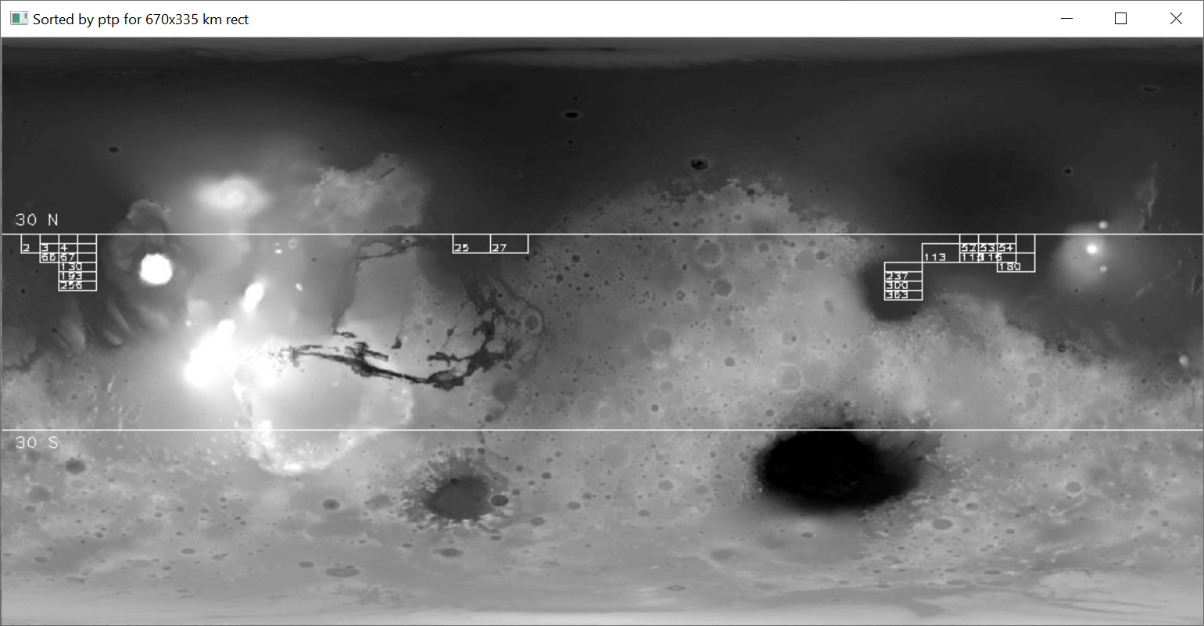

Figure 7-14: The twenty rectangles with the lowest peak-to-valley scores

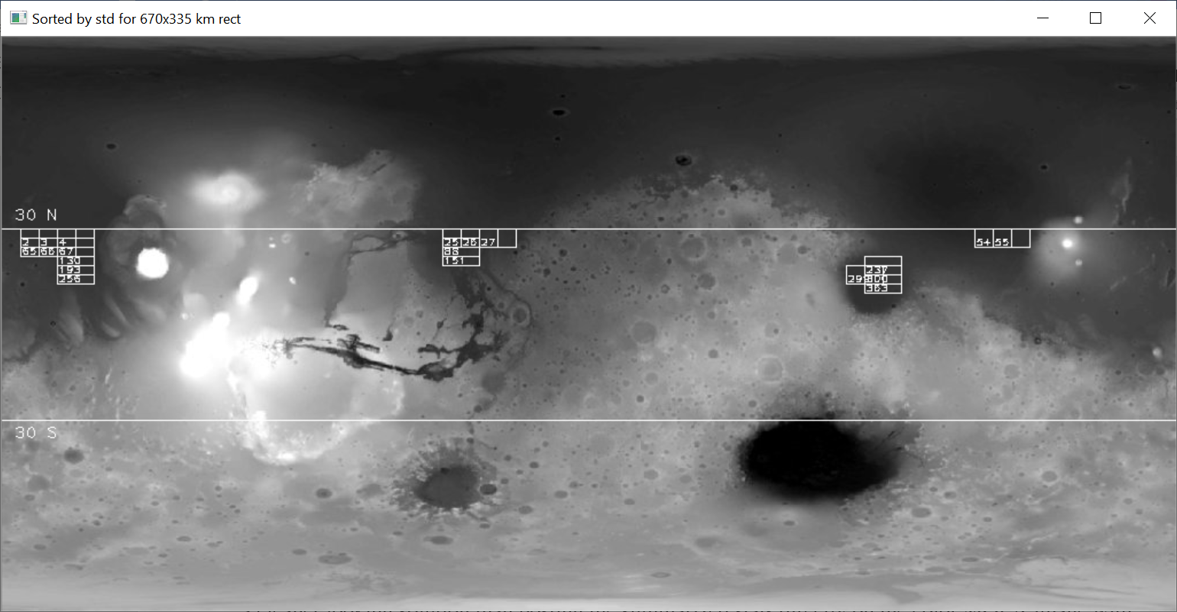

Figure 7-15: The twenty rectangles with the lowest standard deviations

These two figures show the top twenty rectangles for each statistic. That doesn’t mean they always agree. The rectangle with the lowest standard deviation may not appear in the peak-to-valley figure due to the presence of a single small crater. To find the flattest, smoothest rectangles, you need to identify the rectangles that appear in both figures and show them in their own display.

Making the Final Color Display

Listing 7-8 finishes the Search class by defining a method to summarize the best rectangles. It uses tkinter to make a summary window with the rectangles posted on the color MOLA image. It also prints the rectangles’ statistics below as text objects. This adds a little work, but it’s a cleaner-looking solution than posting the summarized stats directly on the image with OpenCV.

def make_final_display(self):

"""Use Tk to show map of final rects & printout of their statistics."""

➊screen.title('Sites by MOLA Gray STD & PTP {} Rect'.format(self.name))

# Draw the high-graded rects on the colored elevation map.

➋img_color_rects = self.draw_filtered_rects(IMG_COLOR,

self.high_graded_rects)

# Convert image from CV BGR to RGB for use with Tkinter.

➌img_converted = cv.cvtColor(img_color_rects, cv.COLOR_BGR2RGB)

➍img_converted = ImageTk.PhotoImage(Image.fromarray(img_converted))

➎canvas.create_image(0, 0, image=img_converted, anchor=tk.NW)

# Add stats for each rectangle at bottom of canvas.

➏txt_x = 5

txt_y = IMG_HT + 20

➐for k in self.high_graded_rects:

canvas.create_text(txt_x, txt_y, anchor='w', font=None,

text="rect={} mean elev={:.1f} std={:.2f} ptp={}"

.format(k, self.rect_means[k], self.rect_stds[k],

self.rect_ptps[k]))

txt_y += 15

➑if txt_y >= int(canvas.cget('height')) - 10:

txt_x += 300

txt_y = IMG_HT + 20

➒canvas.pack()

screen.mainloop()

Listing 7-8: Makes the final display using the color MOLA map, site_selector.py (Part 8)

After defining the method, give the tkinter screen window a title that links to the name of your search object ➊.

Then, to make the final color image for display, name a local variable img_color_rects and call the draw_filtered_rects() method ➋. Pass it the color MOLA image and the list of high-graded rectangles. This will return the colored image with the final rectangles and latitude limits.

Before you can post this new color image in the tkinter canvas, you need to convert the colors from OpenCV’s Blue-Green-Red (BGR) format to the Red-Green-Blue (RGB) format used by tkinter. Do this with the OpenCV cvtColor() method. Pass it the image variable and the COLOR_BGR2RGB flag ➌. Name the result img_converted.

At this point, the image is still a NumPy array. To convert to a tkinter-compatible photo image, you need to use the PIL ImageTk module’s PhotoImage class and the Image module’s fromarray() method ➍. Pass the method the RGB image variable you created in the previous step.

With the image finally tkinter-ready, place it in the canvas using the create_image() method ➎. Pass the method the coordinates of the upper-left corner of the canvas (0, 0), the converted image, and a northwest anchor direction.

Now all that’s left is to add the summary text. Start by assigning coordinates for the bottom-left corner of the first text object ➏. Then begin looping through the rectangle numbers in the high-graded rectangle list ➐. Use the create_text() method to place the text in the canvas. Pass it a pair of coordinates, a left-justified anchor direction, the default font, and a text string. Get the statistics by accessing the different dictionaries using the rectangle number, designated k for “key.”

Increment the text box’s y coordinate by 15 after drawing each text object. Then write a conditional to check that the text is greater than or within 10 pixels of the bottom of the canvas ➑. You can obtain the height of the canvas using the cget() method.

If the text is too close to the bottom of the canvas, you need to start a new column. Shift the txt_x variable over by 300 and reset txt_y to the image height plus 20.

Finish the method definition by packing the canvas ➒ and then calling the screen object’s mainloop(). Packing optimizes the placement of objects in the canvas. The mainloop() is an infinite loop that runs tkinter, waits for an event to occur, and processes the event until the window is closed.

Note: The height of the color image (506 pixels) is slightly larger than that of the grayscale image (501 pixels). I chose to ignore this, but if you’re a stickler for accuracy, you can use OpenCV to shrink the height of the color image using IMG_COLOR = cv.resize(IMG_COLOR, (1024, 501), interpolation = cv.INTER_AREA).

Running the Program with main()

Listing 7-9 defines a main() function to run the program.

def main():

➊app = Search('670x335 km')

➋app.run_rect_stats()

➌app.draw_qc_rects()

➍app.sort_stats()

➎ptp_img = app.draw_filtered_rects(IMG_GRAY, app.ptp_filtered)

std_img = app.draw_filtered_rects(IMG_GRAY, app.std_filtered)

# Display filtered rects on grayscale map.

➏cv.imshow('Sorted by ptp for {} rect'.format(app.name), ptp_img)

cv.waitKey(3000)

cv.imshow('Sorted by std for {} rect'.format(app.name), std_img)

cv.waitKey(3000)

➐app.make_final_display() # Includes call to mainloop().

➑if __name__ == '__main__':

main()

Listing 7-9: Defines and calls the main() function used to run the program, site_selector.py (Part 9)

Start by instantiating an app object from the Search class ➊. Name it 670x335 km to document the size of the rectangular regions being investigated. Next, call the Search methods in order. Run the stats on the rectangles ➋ and draw the quality control rectangles ➌. Sort the statistics from smallest to largest ➍, then draw the rectangles with the best peak-to-valley and standard deviation stats ➎. Show the results ➏ and finish the function by making the final summary display ➐.

Back in the global space, add the code that lets the program run as an imported module or in stand-alone mode ➑.

Figure 7-16 is the final display. It includes the high-graded rectangles and the summary statistics sorted based on standard deviation.

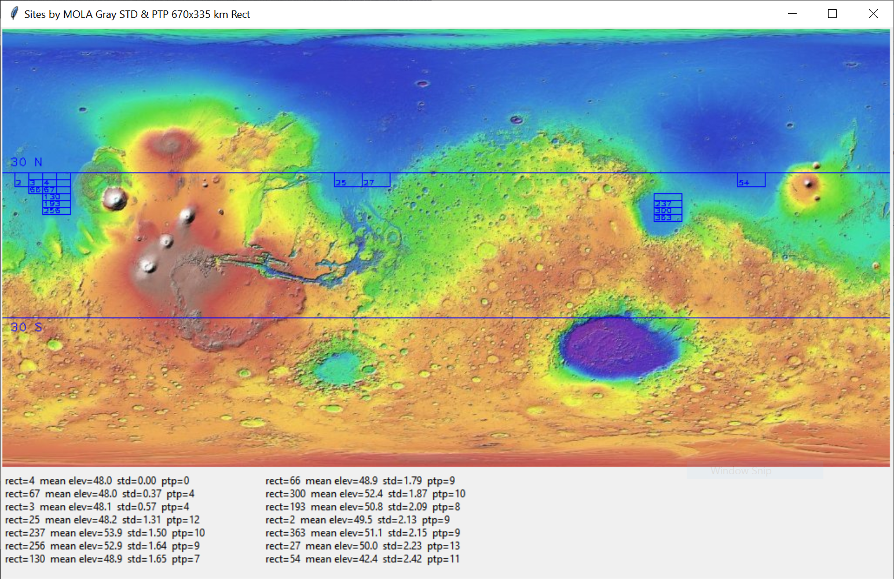

Figure 7-16: Final display with high-graded rectangles and summary statistics sorted by standard deviation

Results

After you’ve made the final display, the first thing you should do is perform a sanity check. Make sure that the rectangles are within the allowed latitude and elevation limits, and that they appear to be in smooth terrain. Likewise, the rectangles based on the peak-to-valley and standard deviation statistics, shown in Figures 7-14 and 7-15, respectively, should match the constraints and mostly pick the same rectangles.

As noted previously, the rectangles in Figures 7-14 and 7-15 don’t perfectly overlap. That’s because you’re using two different metrics for smoothness. One thing you can be sure of, though, is that the rectangles that do overlap will be the smoothest of all the rectangles.

While all the rectangle locations look reasonable in the final display, the concentration of rectangles on the far west side of the map is particularly encouraging. This is the smoothest terrain in the search area (Figure 7-17), and your program clearly recognized it.

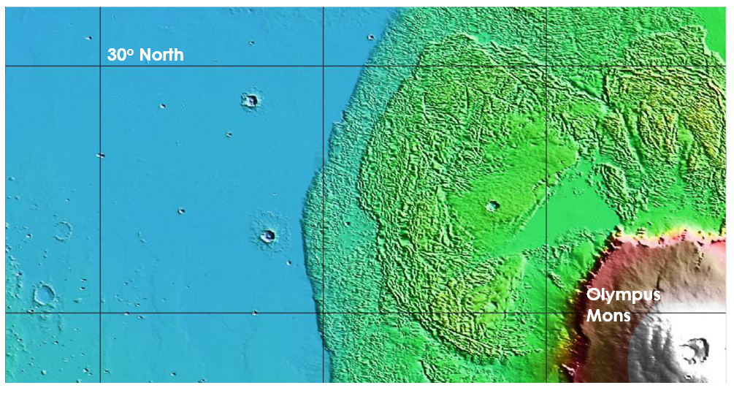

Figure 7-17: The very smooth terrain west of the Olympus Mons lava fields

This project focused on safety concerns, but scientific objectives drive site selection for most missions. In the practice projects at the end of the chapter, you’ll get a chance to incorporate an additional constraint—geology—into the site selection equation.

Summary

In this chapter, you used Python, OpenCV, the Python Imaging Library, NumPy, and tkinter to load, analyze, and display an image. Because OpenCV treats images as NumPy arrays, you can easily extract information from parts of an image and evaluate it with Python’s many scientific libraries.

The dataset you used was quick to download and fast to run. While a real intern would’ve used a larger and more rigorous dataset, such as one comprised of millions of actual elevation measurements, you got to see how the process works with little effort and very reasonable results.

Further Reading

The Jet Propulsion Laboratory has several short and fun videos about landing on Mars. Find them with an online search for “Mars in a Minute: How Do You Choose a Landing Site?”, “Mars in a Minute: How Do You Get to Mars?”, and “Mars in a Minute: How Do You Land on Mars?”

Mapping Mars: Science, Imagination, and the Birth of a World (Picador, 2002) by Oliver Morton, tells the story of the contemporary exploration of Mars, including the creation of the MOLA map.

The Atlas of Mars: Mapping its Geography and Geology (Cambridge University Press, 2019) by Kenneth Coles, Kenneth Tanaka, and Philip Christensen, is a spectacular all-purpose reference atlas of Mars that includes maps of topography, geology, mineralogy, thermal properties, near-surface water-ice, and more.

The data page for the MOLA map used in Project 10 can be found at <https://astrogeology.usgs.gov/search/map/Mars/GlobalSurveyor/MOLA/Mars_MGS_MOLA_DEM_mosaic_global_463m>.

Detailed Martian datasets can be found at the Mars Orbital Data Explorer site produced by the PDS Geoscience Node at Washington University in St. Louis (<https://ode.rsl.wustl.edu/mars/index.aspx>).

Practice Project: Confirming that Drawings Become Part of an Image

Write a Python program that verifies that drawings added to an image, such as text, lines, rectangles, and so on, become a part of that image. Use NumPy to calculate the mean, standard deviation, and peak-to-valley on a rectangular region in the MOLA grayscale image, but don’t draw the rectangle outline. Then draw a white line around the region and rerun the stats. Do the two runs agree?

You can find a solution, practice_confirm_drawing_part_of_image.py, in the Appendix or Chapter_7 folder, downloadable from https/XXXXX.

Practice Project: Extracting an Elevation Profile

An elevation profile is a two-dimensional, cross-sectional view of a landscape. It provides a side view of a terrain's relief along a line drawn between locations on a map. Geologists can use profiles to study the smoothness of a surface and visualize its topography. For this practice project, draw a west-to-east profile that passes through the caldera of the largest volcano in the solar system, Olympus Mons (Figure 7-18).

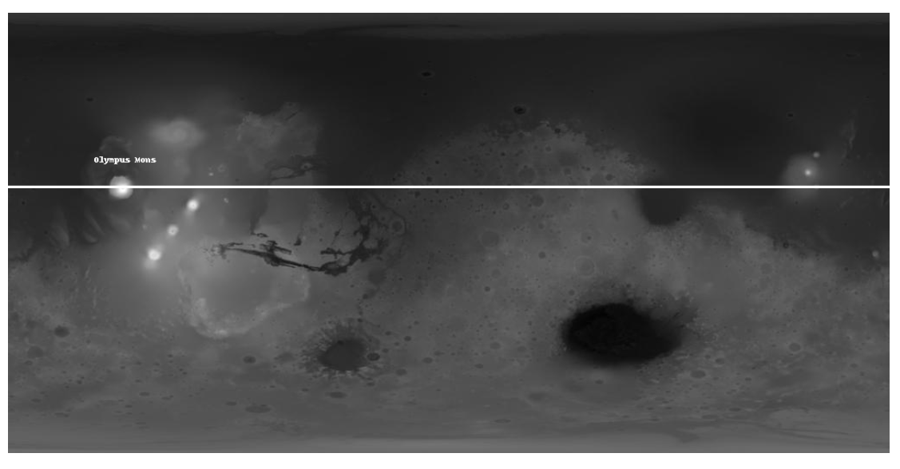

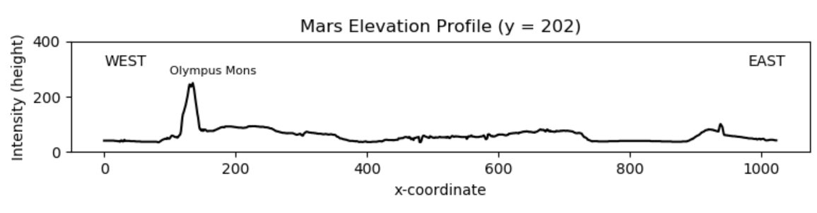

Figure 7-18: Vertically exaggerated west-east profile through Olympus Mons

Use the Mars MGS MOLA - MEX HRSC Blended DEM Global 200m v2 map shown in Figure 7-20. This version has better lateral resolution than the one you used for Project 10. It also uses the full elevation range in the MOLA data. You can find a copy, mola_1024x512_200mp.jpg, in the Chapter_7 folder, downloadable from the book’s website. A solution, practice_profile_olympus.py, can be found in the same folder and in the Appendix.

Practice Project: Plotting in 3D

Mars is a very asymmetrical planet, with the southern hemisphere dominated by ancient cratered highlands and the north characterized by smooth, flat lowlands. To make this more apparent, use the 3D plotting functionality in matplotlib to display the mola_1024x512_200mp.jpg image you used in the previous practice project (Figure 7-19).

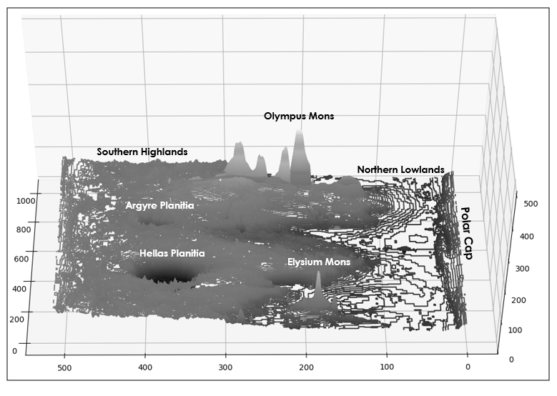

Figure 7-19: A 3D contour plot of Mars, looking toward the west

With matplotlib, you can make 3D relief plots using points, lines, contours, wireframes, and surfaces. Although the plots are somewhat crude, you can generate them quickly. You can also use the mouse to interactively grab the plot and change the viewpoint. They are particularly useful for people who have trouble visualizing topography from 2D maps.

In Figure 7-19, the exaggerated vertical scale makes the elevation difference from south to north easy to see. It’s also easy to spot the tallest mountain (Olympus Mons) and the deepest crater (Hellas Planitia).

You can reproduce the plot in Figure 7-19—sans annotation—with the practice_3d_plotting.py program in the Appendix or Chapter_7 folder, downloadable from the book’s website. The map image can be found in the same folder.

Practice Project: Mixing Maps

Make up a new project that adds a bit of science to the site-selection process. Combine the MOLA map with a color geology map and find the smoothest rectangular regions within the volcanic deposits at Tharsis Montes (see arrow in Figure 7-20).

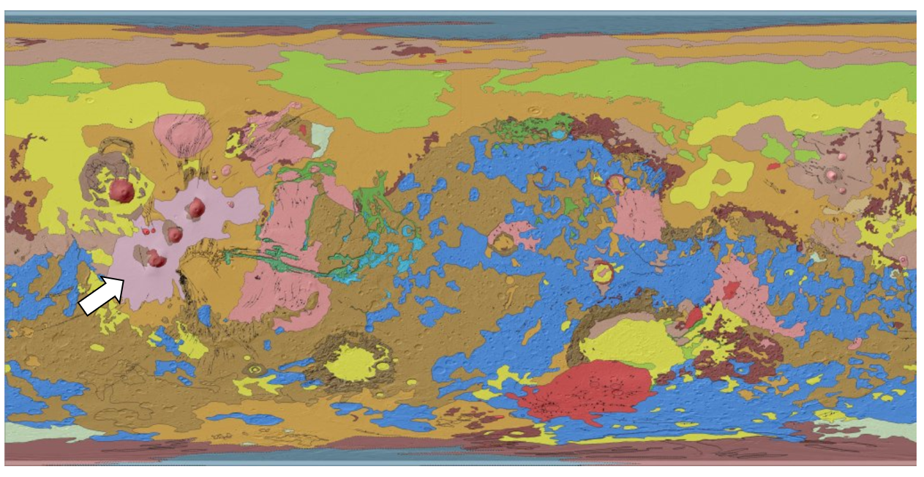

Figure 7-20: Geological map of Mars. The arrow points to volcanic deposits on Tharsis Montes. Courtesy of NASA.

Since the Tharsis Montes region lies at a high altitude, focus on finding the flattest and smoothest parts of the volcanic deposits, rather than targeting the lowest elevations. To isolate the volcanic deposits, consider thresholding a grayscale version of the map.

With thresholding, you convert a grayscale image into a binary image where pixels above or between specified threshold values are set to 1, and all others are set to 0. You can use this binary image to filter the MOLA map, as shown in Figure 7-21.

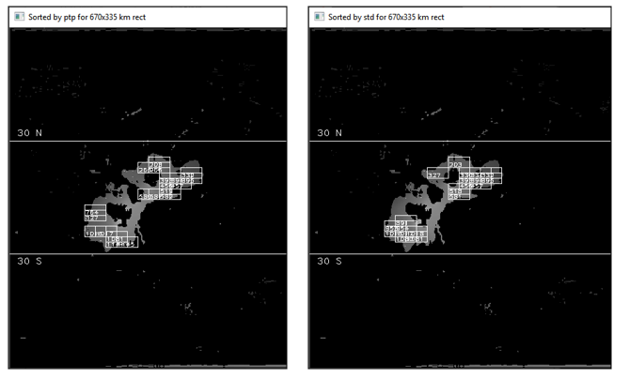

Figure 7-21: Filtered MOLA map over the Tharsis Montes region, with ptp (left) and std (right) rectangles

You can find the geological map, Mars_Global_Geology_Mariner9_1024.jpg, in the Chapter_7 folder, downloadable from the book’s website. The volcanic deposits will be light pink in color. For the elevation map, use the mola_1024x512_200mp.jpg from the “Extracting an Elevation Profile” practice project on Page XX.

A solution, practice_geo_map_step_1of2.py and practice_geo_map_step_2of2.py, can be found in the same folder and in the Appendix. Run the practice_geo_map_step_1of2.py program first to generate the filter for step 2.

Challenge Project: Making it Three in a Row

Edit the previous Practice Project so that the profile passes through the three volcanoes on Tharsis Montes, as shown in Figure 7-22.

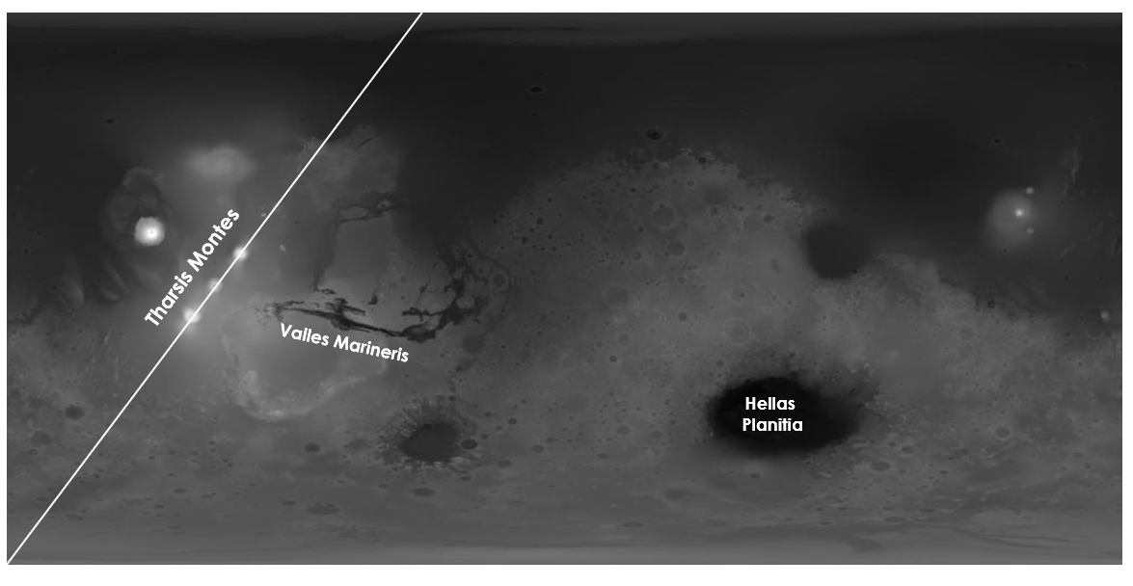

Figure 7-22: Diagonal profile through the three volcanoes on Tharsis Montes

Other interesting features to profile are Valles Marineris, a canyon five times as long and four times as deep as the Grand Canyon, and Hellas Planitia, considered the third or fourth largest impact crater in the solar system (Figure 7-22).

Challenge Project: Wrapping Rectangles

Edit the site_selector.py code so that it accommodates rectangle dimensions that don’t divide evenly into the width of the MOLA image. One way to do this is to add code that splits the rectangle into two pieces—one along the right edge of the map and the other along the left edge—calculates statistics for each, then recombines them into a full rectangle. Another approach is to duplicate the image and “stitch” it to the original image, as shown in Figure 7-23. This way, you won’t have to split the rectangles, just decide when to stop stepping them across the map.

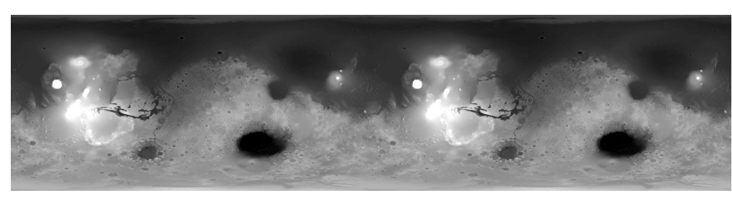

Figure 7-23: The grayscale MOLA image duplicated and repeated